**Cramer’s Rule**

Cramer’s rule is one of the important methods applied to solve a system of equations. In this method, the values of the variables in the system are to be calculated using the determinants of matrices. Thus, Cramer’s rule is also known as the determinant method.

Consider a system of linear equations with n variables x₁, x₂, x₃, …, xₙ written in the matrix form AX = B.

Here,

A = Coefficient matrix (must be a square matrix)

X = Column matrix with variables

B = Column matrix with the constants (which are on the right side of the equations)

Now, we have to find the determinants as:

D = |A|, Dx1, Dx2, Dx3,…, Dxn

Here, Dxi for i = 1, 2, 3,…, n is the same determinant as D such that the column is replaced with B.

Thus,

x1 = Dx1/D; x2 = Dx2/D; x3 = Dx3/D; ….; xn = Dxn/D {where D is not equal to 0}

Let’s have a look at the formulas of Cramer’s rule for 2×2 and 3×3 matrices.

**Cramer’s Rule 2×2**

Cramer’s rule for the 2×2 matrix is applied to solve the system of equations in two variables.

Let us consider two linear equations in two variables.

a1x + b1y = c1

a2x + b2y = c2

Let us write these two equations in the form of AX = B.

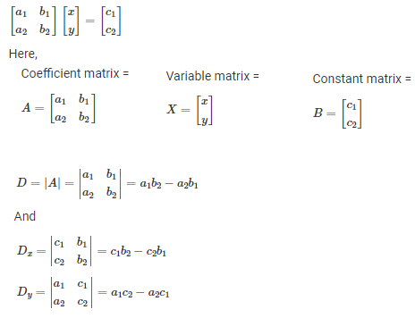



### Cramer’s Rule Example – 2×2

Solve the following system of equations using Cramer’s rule:

2x – y = 5

x + y = 4

**Solution:**

Given,

2x – y = 5

x + y = 4

Let us write these equations in the form AX = B.

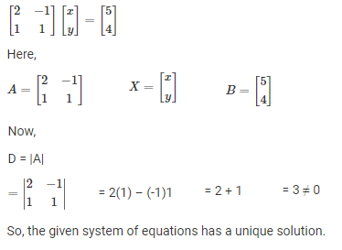

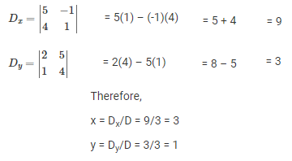

## Cramer’s Rule 3×3

Formula to Find the Determinant of a 3⨉3 Matrix

* Given a 3⨉3 matrix

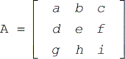

* Its determinant can be calculated using the following formula.

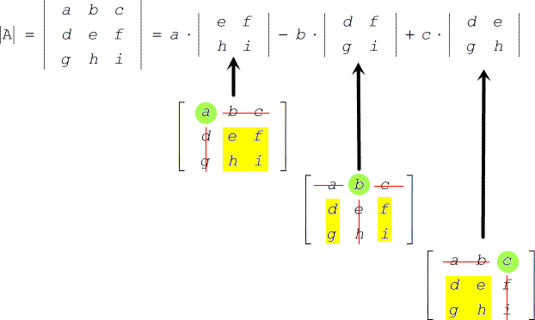

Example:

Find the determinant of matrix A

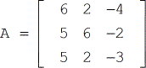

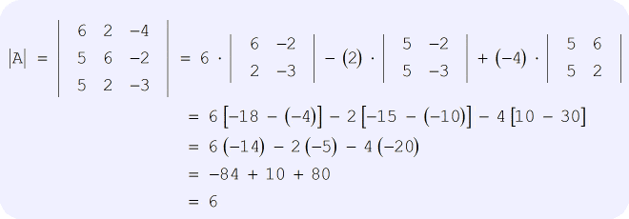

Now, it’s time to go over the procedure on how to use Cramer’s Rule in a linear system involving three variables.

Cramer’s Rules for Systems of Linear Equations with Three Variables

* Given a linear system

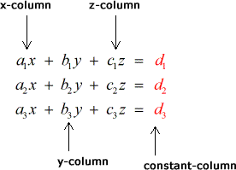

* Labeling each of the four matrices

**Coefficient matrix:**

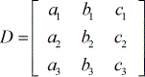

**X – matrix:**

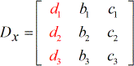

**Y – matrix:**

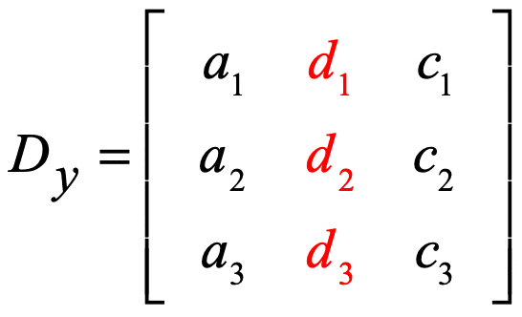

**Z – matrix:**

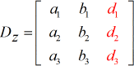

* To solve for x:

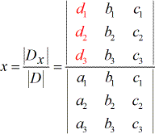

* To solve for y:

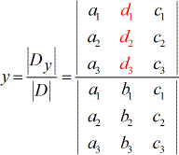

* To solve for z:

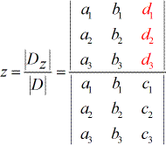

**Things to observe from the setup above:**

* 1. The coefficients of variables x, y, and z make use of subscripted a, b, and c, respectively. While the constant terms use subscripted d.
  2. The denominators to find the values of x, y, and z are all the same which is the determinant of the coefficient matrix (coefficients coming from the columns of x, y, and z).
  3. To solve for x, the coefficients of the x−column is replaced by the constant column (in red).
  4. To solve for y, the coefficients of the y−column is replaced by the constant column (in red).
  5. In the same manner, to solve for z, the coefficients of the z−column is replaced by the constant column (in red).

### Cramer’s Rule Example – 3×3

**Question:**

Solve the following system of equations using Cramer’s rule:

x + y + z =6

y + 3z = 11

x + z =2y or x – 2y + z = 0

**Solution:**

Given,

x + y + z =6

y + 3z = 11

x + z =2y or x – 2y + z = 0

Let us write these equations in the form AX = B.

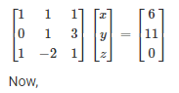

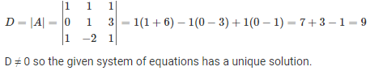

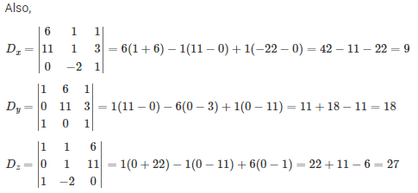

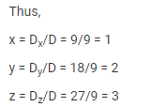

**Cramer’s Rule Questions**

1. Solve the following system of equations by Cramer’s rule:

2x – 3y + 5z = 11

3x + 2y – 4z = – 5

x + y – 2z = – 3

1. Solve the following system of linear equations using Cramer’s rule:

5x + 7y = -2

4x + 6y = -3

**More Examples**

1. Solve the following systems of linear equations by Cramer’s rule:

(i) 5*x*- 2 *y*+16 = 0, *x*+ 3*y*- 7 = 0

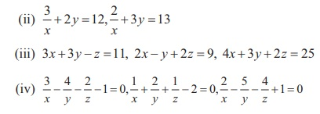

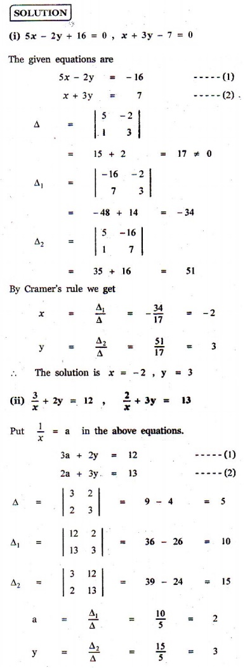

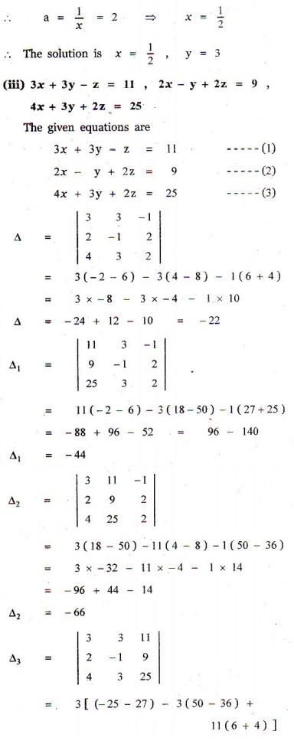

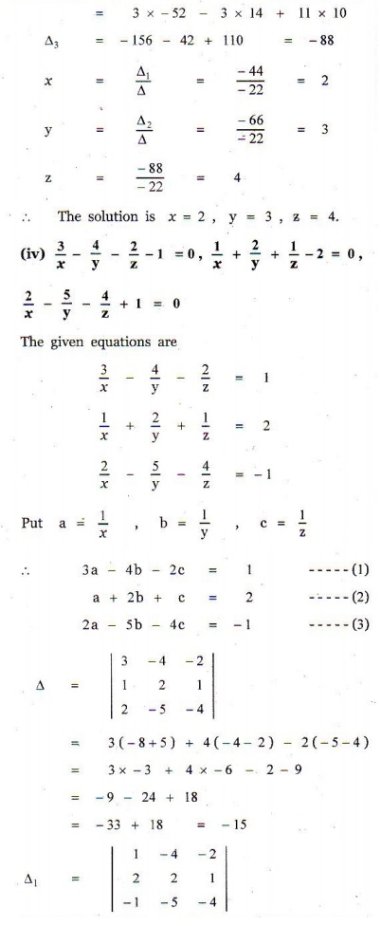

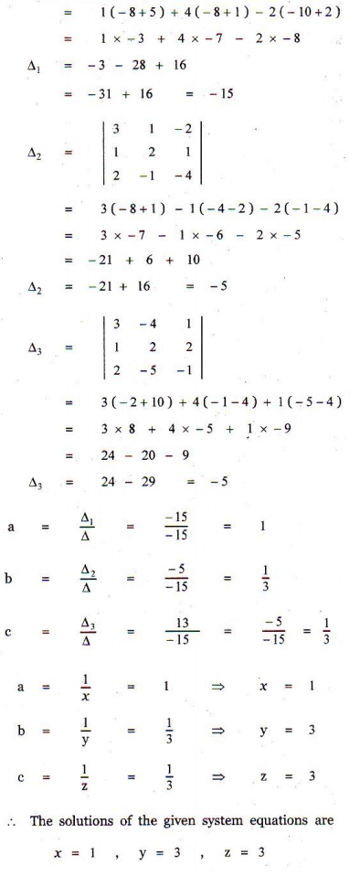

2. In a competitive examination, one mark is awarded for every correct answer while ¼ mark is deducted for every wrong answer. A student answered 100 questions and got 80 marks. How many questions did he answer correctly ? (Use Cramer’s rule to solve the problem).

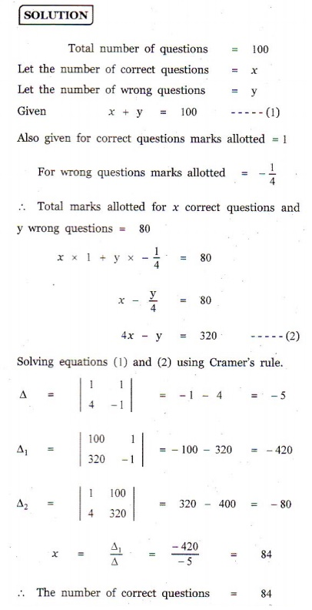

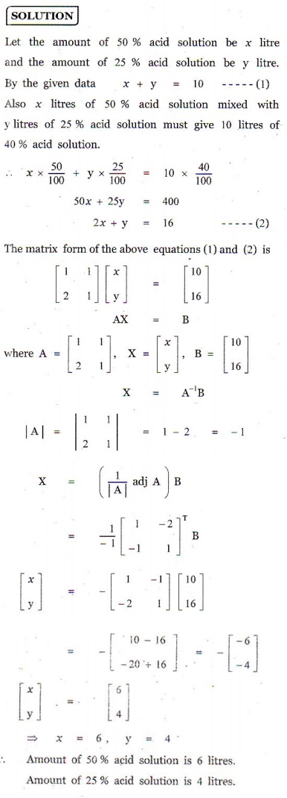3. A chemist has one solution which is 50% acid and another solution which is 25% acid. How much each should be mixed to make 10 litres of a 40% acid solution ? (Use Cramer’s rule to solve the problem).

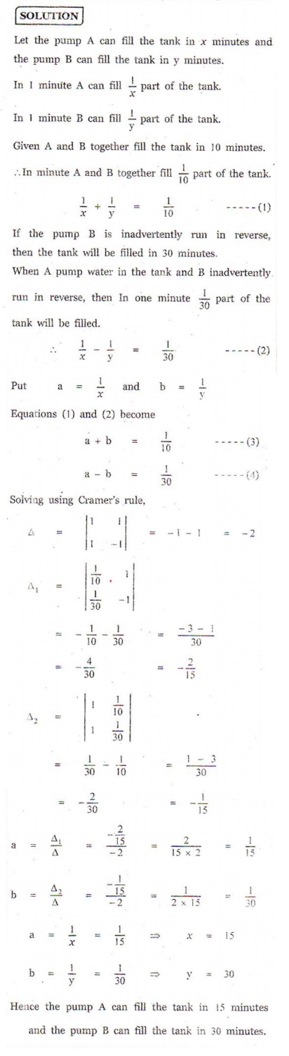4. A fish tank can be filled in 10 minutes using both pumps A and B simultaneously. However, pump B can pump water in or out at the same rate. If pump B is inadvertently run in reverse, then the tank will be filled in 30 minutes. How long would it take each pump to fill the tank by itself ? (Use Cramer’s rule to solve the problem).

5. A family of 3 people went out for dinner in a restaurant. The cost of two dosai, three idlies and two vadais is ₹ 150. The cost of the two dosai, two idlies and four vadais is ₹ 200. The cost of five dosai, four idlies and two vadais is ₹ 250. The family has ₹ 350 in hand and they ate 3 dosai and six idlies and six vadais. Will they be able to manage to pay the bill within the amount they had ?

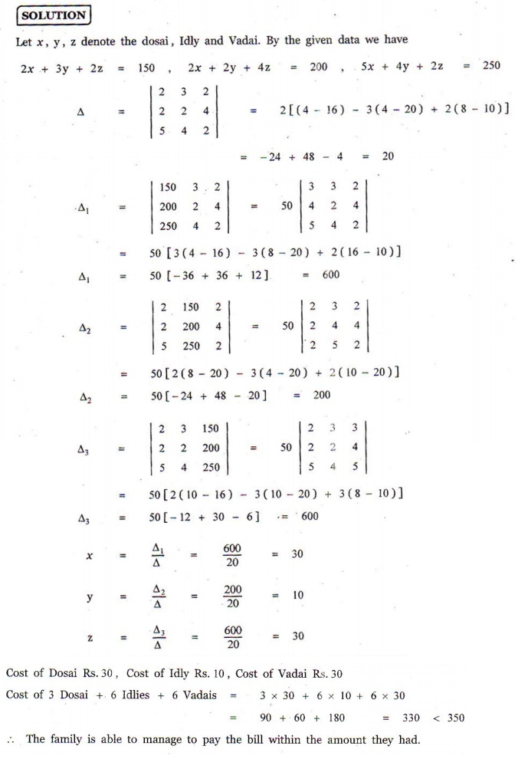

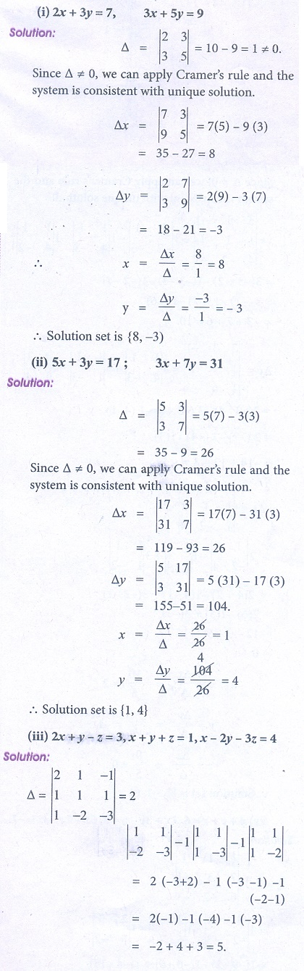**Answers for Exercise 1.4:**

1. (i) x = -2, y = 3

(ii) x = 1/2 , y = 3

(iii) x = 2, y = 3, z = 4

(iv) x = 1, y = 3, z = 3

2. 84

3. 50% acid is 6 litres, 25% acid is 4 litres

4. Pump A : 15 minutes, Pump B : 30 minutes

5. ₹ 30/-, ₹ 10/-, ₹ 30/-, yes

**More Exercise**

1. Solve the following equations by using Cramer’s rule

(i) 2x + 3y = 7; 3x + 5y = 9

(ii) 5x + 3y = 17; 3x + 7 y = 31

(iii) 2x + y − z = 3, x + y + z = 1, x − 2 y − 3z = 4

(iv) x + y + z = 6, 2x + 3y − z = 5, 6x − 2 y − 3z = − 7

(v) x + 4 y + 3z = 2, 2x − 6 y + 6z = −3, 5x − 2 y + 3z = −5

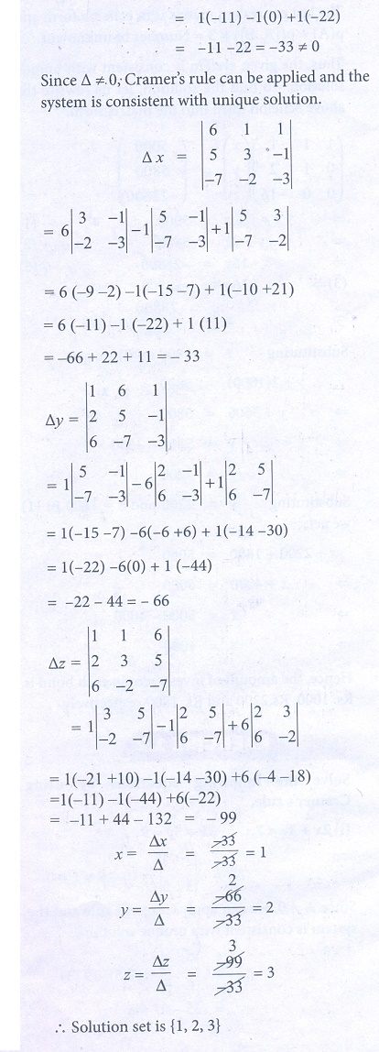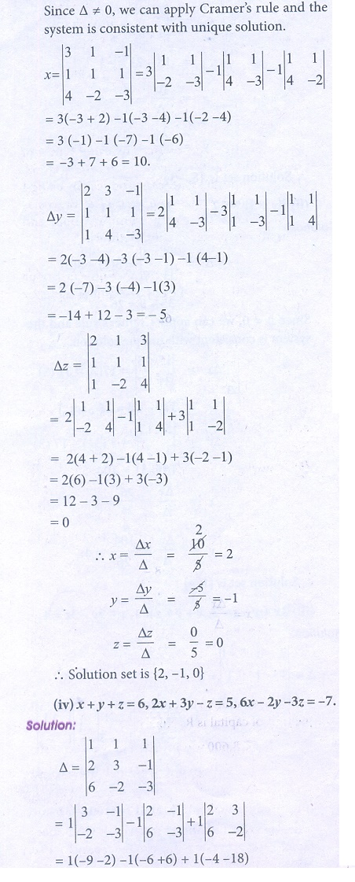

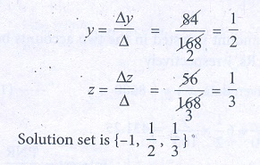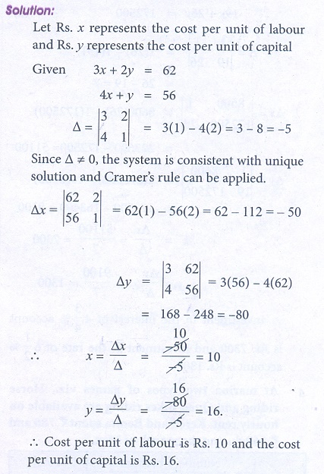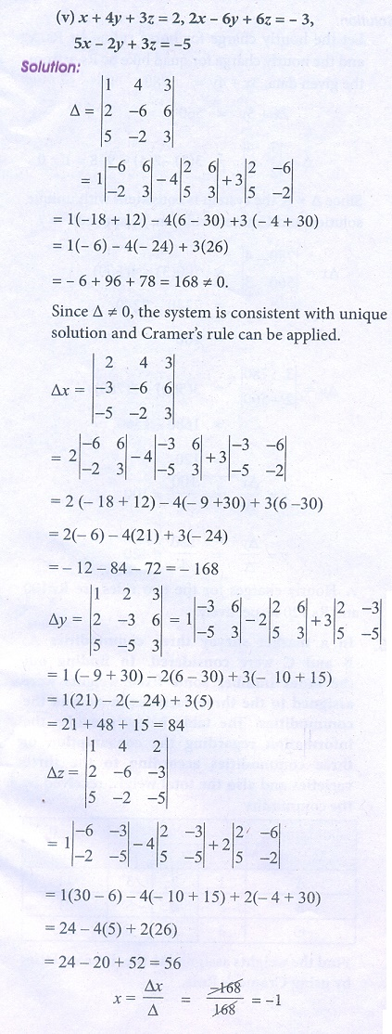2. A commodity was produced by using 3 units of labour and 2 units of capital, the total cost is ₹62. If the commodity had been produced by using 4 units of labour and one unit of capital, the cost is ₹56. What is the cost per unit of labour and capital? (Use determinant method).

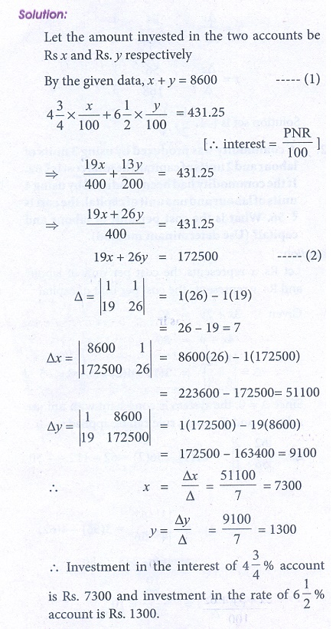3. A total of ₹8,600 was invested in two accounts. One account earned 4 3/4 % annual1 interest and the other earned 6 1/2 % annual interest. If the total interest for one year was ₹431.25, how much was invested in each account? (Use determinant method).

4. At marina two types of games viz., Horse riding and Quad Bikes riding are available on hourly rent. Keren and Benita spent ₹780 and ₹560 during the month of May.

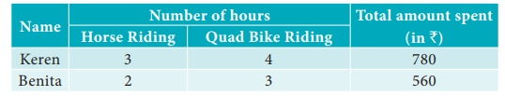

Find the hourly charges for the two games (rides). (Use determinant method).

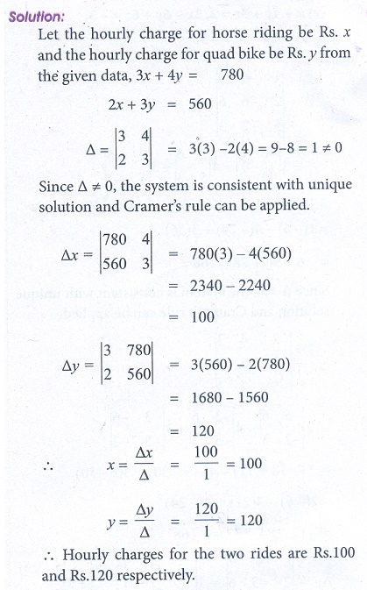

5. In a market survey three commodities A, B and C were considered. In finding out the index number some fixed weights were assigned to the three varieties in each of the commodities. The table below provides the information regarding the consumption of three commodities according to the three varieties and also the total weight received by the commodity

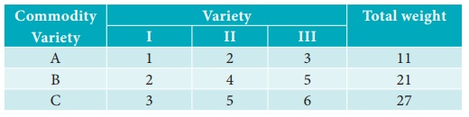

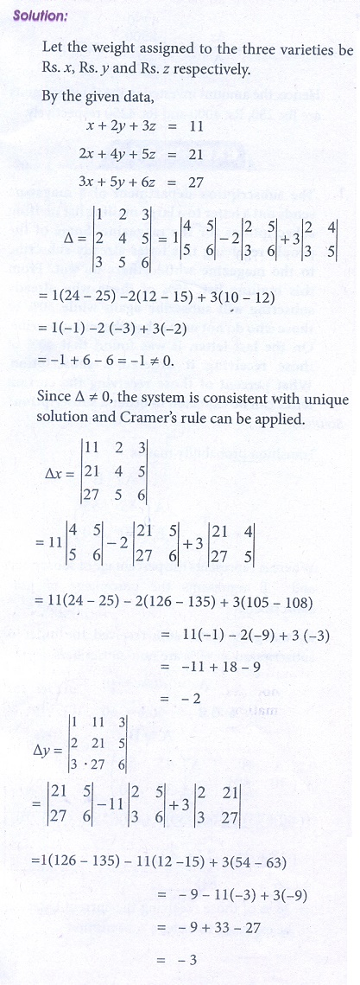Find the weights assigned to the three varieties by using Cramer’s Rule.

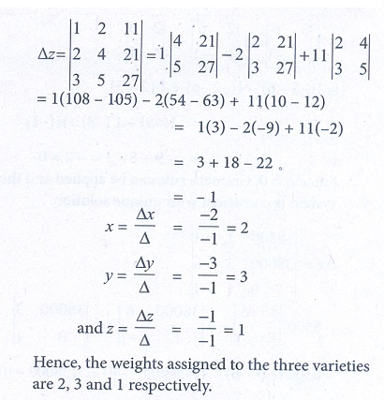

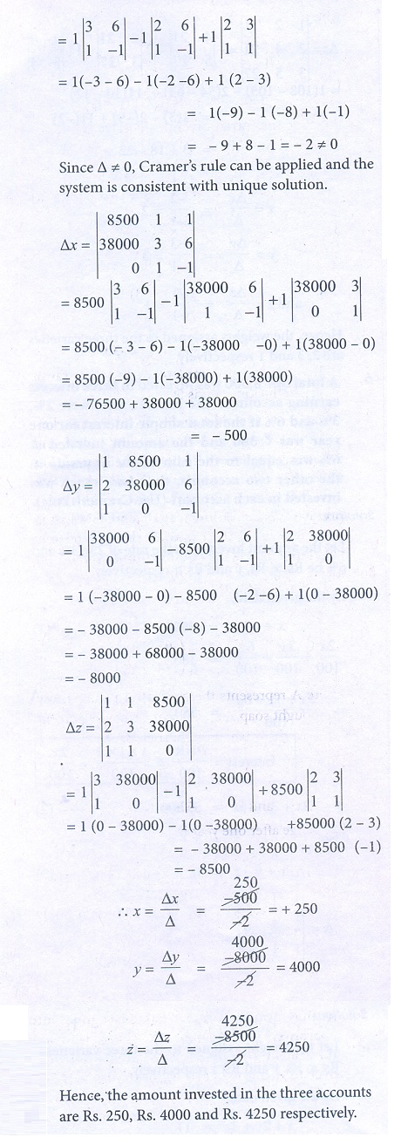6. A total of ₹8,500 was invested in three interest earning accounts. The interest rates were 2%, 3% and 6% if the total simple interest for one year was ₹380 and the amount invested at 6% was equal to the sum of the amounts in the other two accounts, then how much was invested in each account? (use Cramer’s rule).

